**BBL733**

Restriction and other modifying enzymes, Cloning vectors (plasmid, (-based, phagemids, high capacity) and expression vectors, Expression in bacterial, yeast and mammalian systems, Construction of genomic and cDNA libraries, DNA Sequencing, Polymerase chain reaction, Invitro mutagenesis, Genome mapping, Stability of recombinant cells in production of biochemicals.

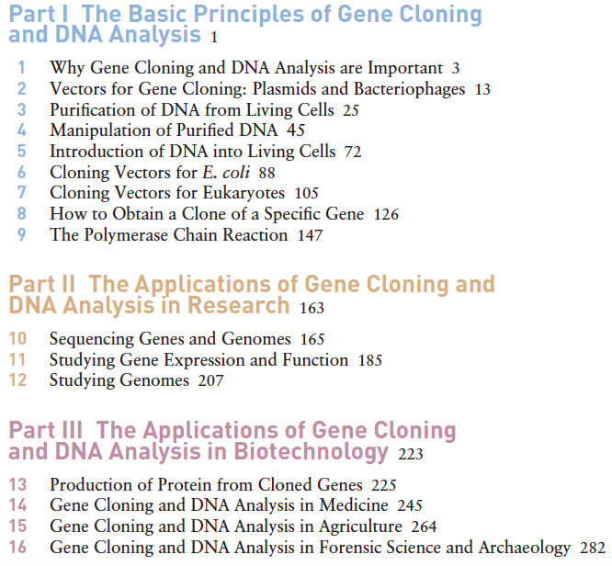

**MINOR -27**

**MAJOR- 27**

**PRACTICAL QUIZ- 20 + 5 marks file**

**ASSIGNMENTS 21**

**Attendance policy- 75% or 1 grade less**

This assignment will help you in understanding the workflow for any gene cloning work. You will learn how to download a gene sequence and understand its features. You will also learn how to design primers for making an N-terminal or C-terminal fusion construct. Further, you will learn how to extract the promoter sequence of any gene and design primers for its cloning. You will also learn how to design primers for mutating a gene. The link for the lectures helpful for these will be shared.

Everybody will be assigned a gene to work upon.

1. You need to provide the gene length, coding sequence length, no of exons and introns, no-of alternatively spliced forms for the specific gene that has been assigned to you (2  marks)

2. Provide the sequence of the forward and reverse primers for cloning the coding sequence with an N-terminal fusion tag (FLAG-TAG) in a mammalian expression vector pcDNA3.1 (+)  (2 marks)

3. Design primers for cloning the coding sequence with a N-terminal (His-Tag) in a pET vector  (2 marks)

4. Provide the sequence of forward and reverse primers for cloning the -1 kb region upstream of the transcription start site in a pGL3 basic vector   (2 marks)

5. Provide the sequence of primers for mutating any three bp in the construct you had cloned in pGL3 basic vector       (2 marks)

6. Design siRNA for knocking down your gene of interest (2 marks)

7. Design shRNA clone for knocking down your gene of interest. (2 marks)

8. Design primers for reverse-transcription PCR mediated detection of your transcript (one primer should be from intron-exon boundary) (2 marks)

9. You all need to cover any 1 biotechnology-related research work (5 marks) published in the past two years. You may use any search engines such as those given below but not limited to these. Needless to say that there should be NO overlap in your submitted reports and those of other students. It should be covered in 1-2 page write up (Times New Roman, Font size- 12, Line spacing- 1.15) describing the study in your own words categorized into the following subheadings- Title, Authors, Research group address (University/Institute Name), Background, Methodology, Findings (No more than 15 % similarity match should be there in the submitted reports-Turnitin).

<https://www.nature.com/subjects/biotechnology>

<https://www.sciencedaily.com/news/plants_animals/biotechnology/>

<https://www.genengnews.com/>

<https://www.the-scientist.com/tag/biotechnology>

[https://www.biotecnika.org/category/biotech-news/](https://www.bionews.org.uk/page_2424)

<https://www.bionews.org.uk/page_2424>